

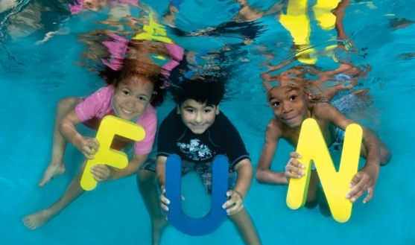

Party package includes:
- Invitations.
- Party coordinator to ensure your party runs smoothly
- Private Section of the Pool
- Lifeguard Supervision
- A choice of hot meals/drinks from McDonalds, Centra or Supermacs
- Served in our Party Room
- Up to 18 Children per party
- Gift for the Birthday Child

Party Package cost: €12 per child
Minimum charge: €120 (10 children)
Deposit of €48 is needed to secure booking

To book contact reception or
Phone 065 6821604


KIDS CAMP
Mon 21st–Wed 23rd Dec &
Mon 28th- Thurs 31st Dec 15
10am-1pm Activities Include, Arts & Crafts, Mini Swim Lessons, Games in Aerobics Studio and much more –
Cost: €12 PER DAY
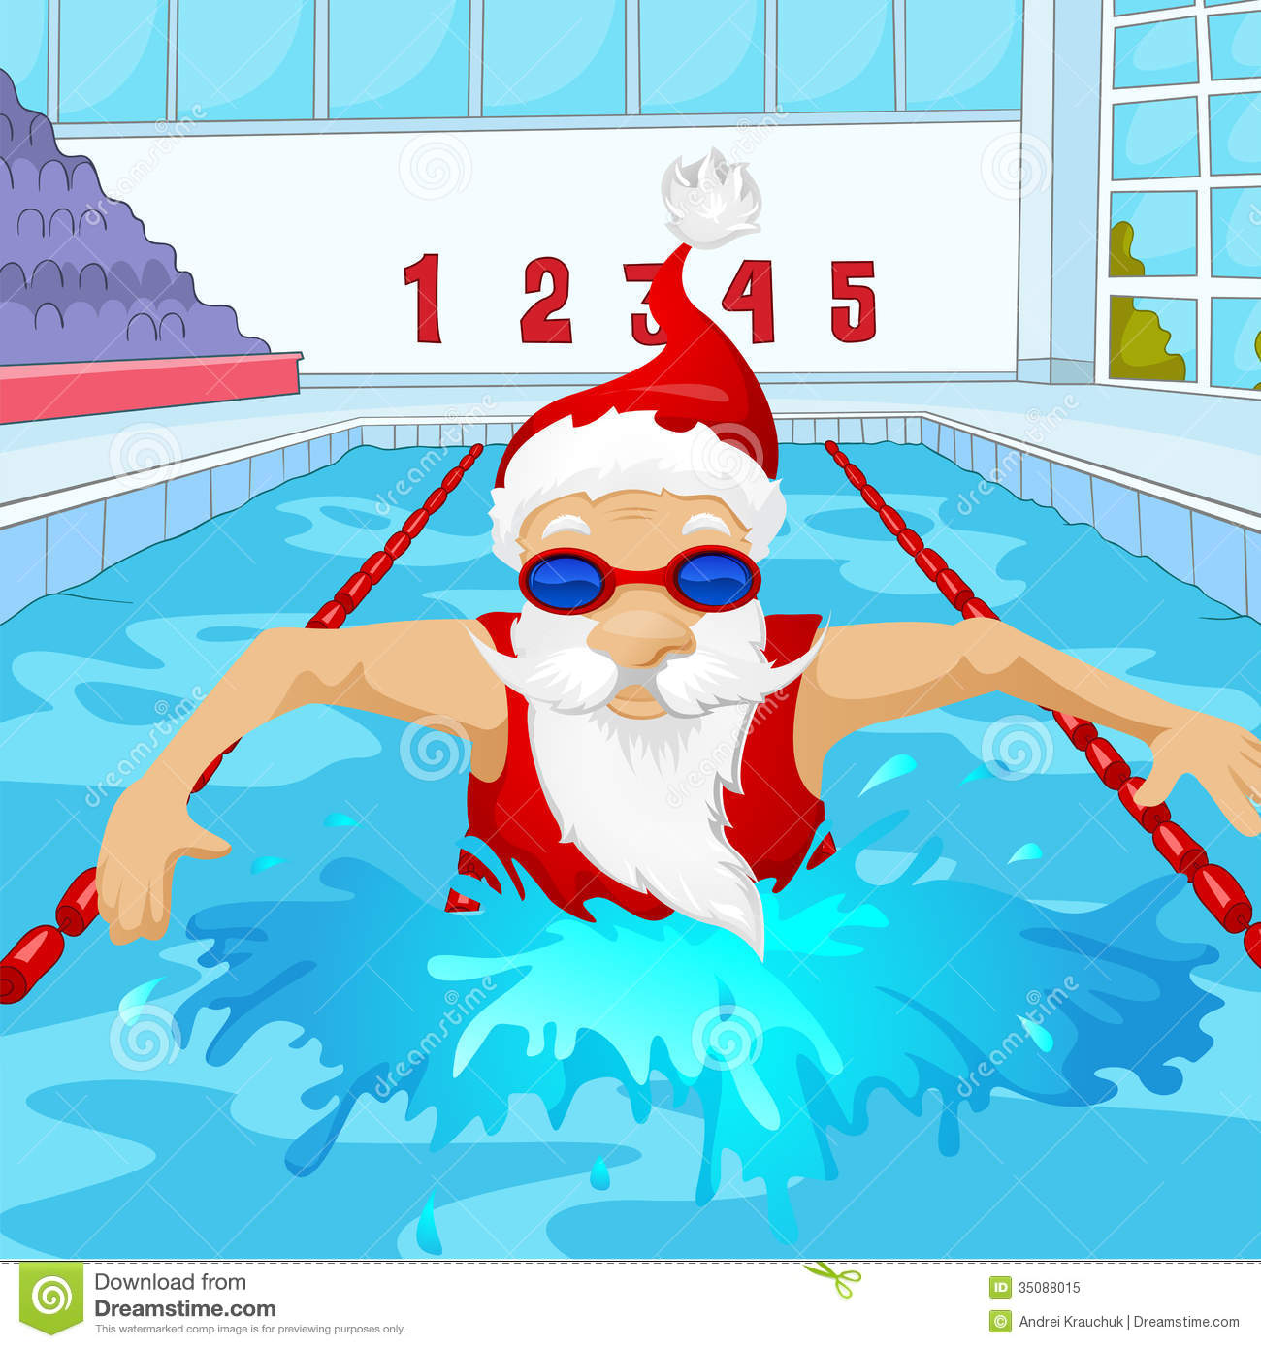
INTENSIVE SWIM LESSONS Mon 21st–Wed 23rd Dec &
Mon 28th- Thurs 31st Dec 15

11–11.45am – Beginners, Improvers & Advanced Levels Daily

- Guaranteed small groups
- More individual attention
- Great progress made in a few days
Cost: €10 per day
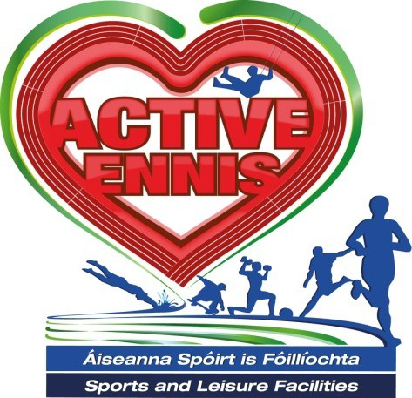

Nov/Dec 2015
Fitness Classes
Membership Offers

Kids Camps & Birthday Parties

Adult & Kids Swimming Lessons

Contact
065 6821604

Visit www.activeennis.ie for up-to-date news and our full range of classes/courses and Pool and Gym timetables Active Ennis Leisure Complex

KIDS SWIMMING LESSONS

7 WEEK COURSE, TERM-TIME
€65 first child, €60 each additional sibling
Starts from Sat/Sun 9/10 Jan 16 & from Mon 11 Jan 2016
Bookings open to Public from 14 Dec 15

ADULT SWIMMING LESSONS
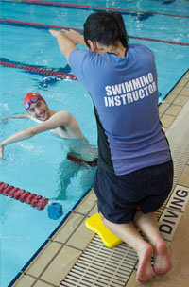
7 WEEK COURSE - €70
Beginners, Improvers & Advanced
Next Course starts – 12th Nov 15
Classes every Thursday
8.45pm – 9.45pm

KEEP UPTO DATE WITH ALL NEW CLASSES AND INFO BY CLICKING ‘LIKE’ ON OUR FACEBOOK PAGE ACTIVE ENNIS


MEMBERSHIPS
DECEMBER SPECIAL
GYM & POOL (1 MONTH)
1st Dec – 31st Dec 2015
€45
JANUARY 3 MONTH SPECIAL
GOLD OPTION
GYM & POOL (3 MONTH)
1ST Jan 2016 – 31st March 2016
€120
JANUARY 12 MONTH SPECIAL
PLATINUM OPTION
(1 YEAR)
1st Jan 2016 – 31st Dec 2016
€380
Free Gym assessment with all memberships

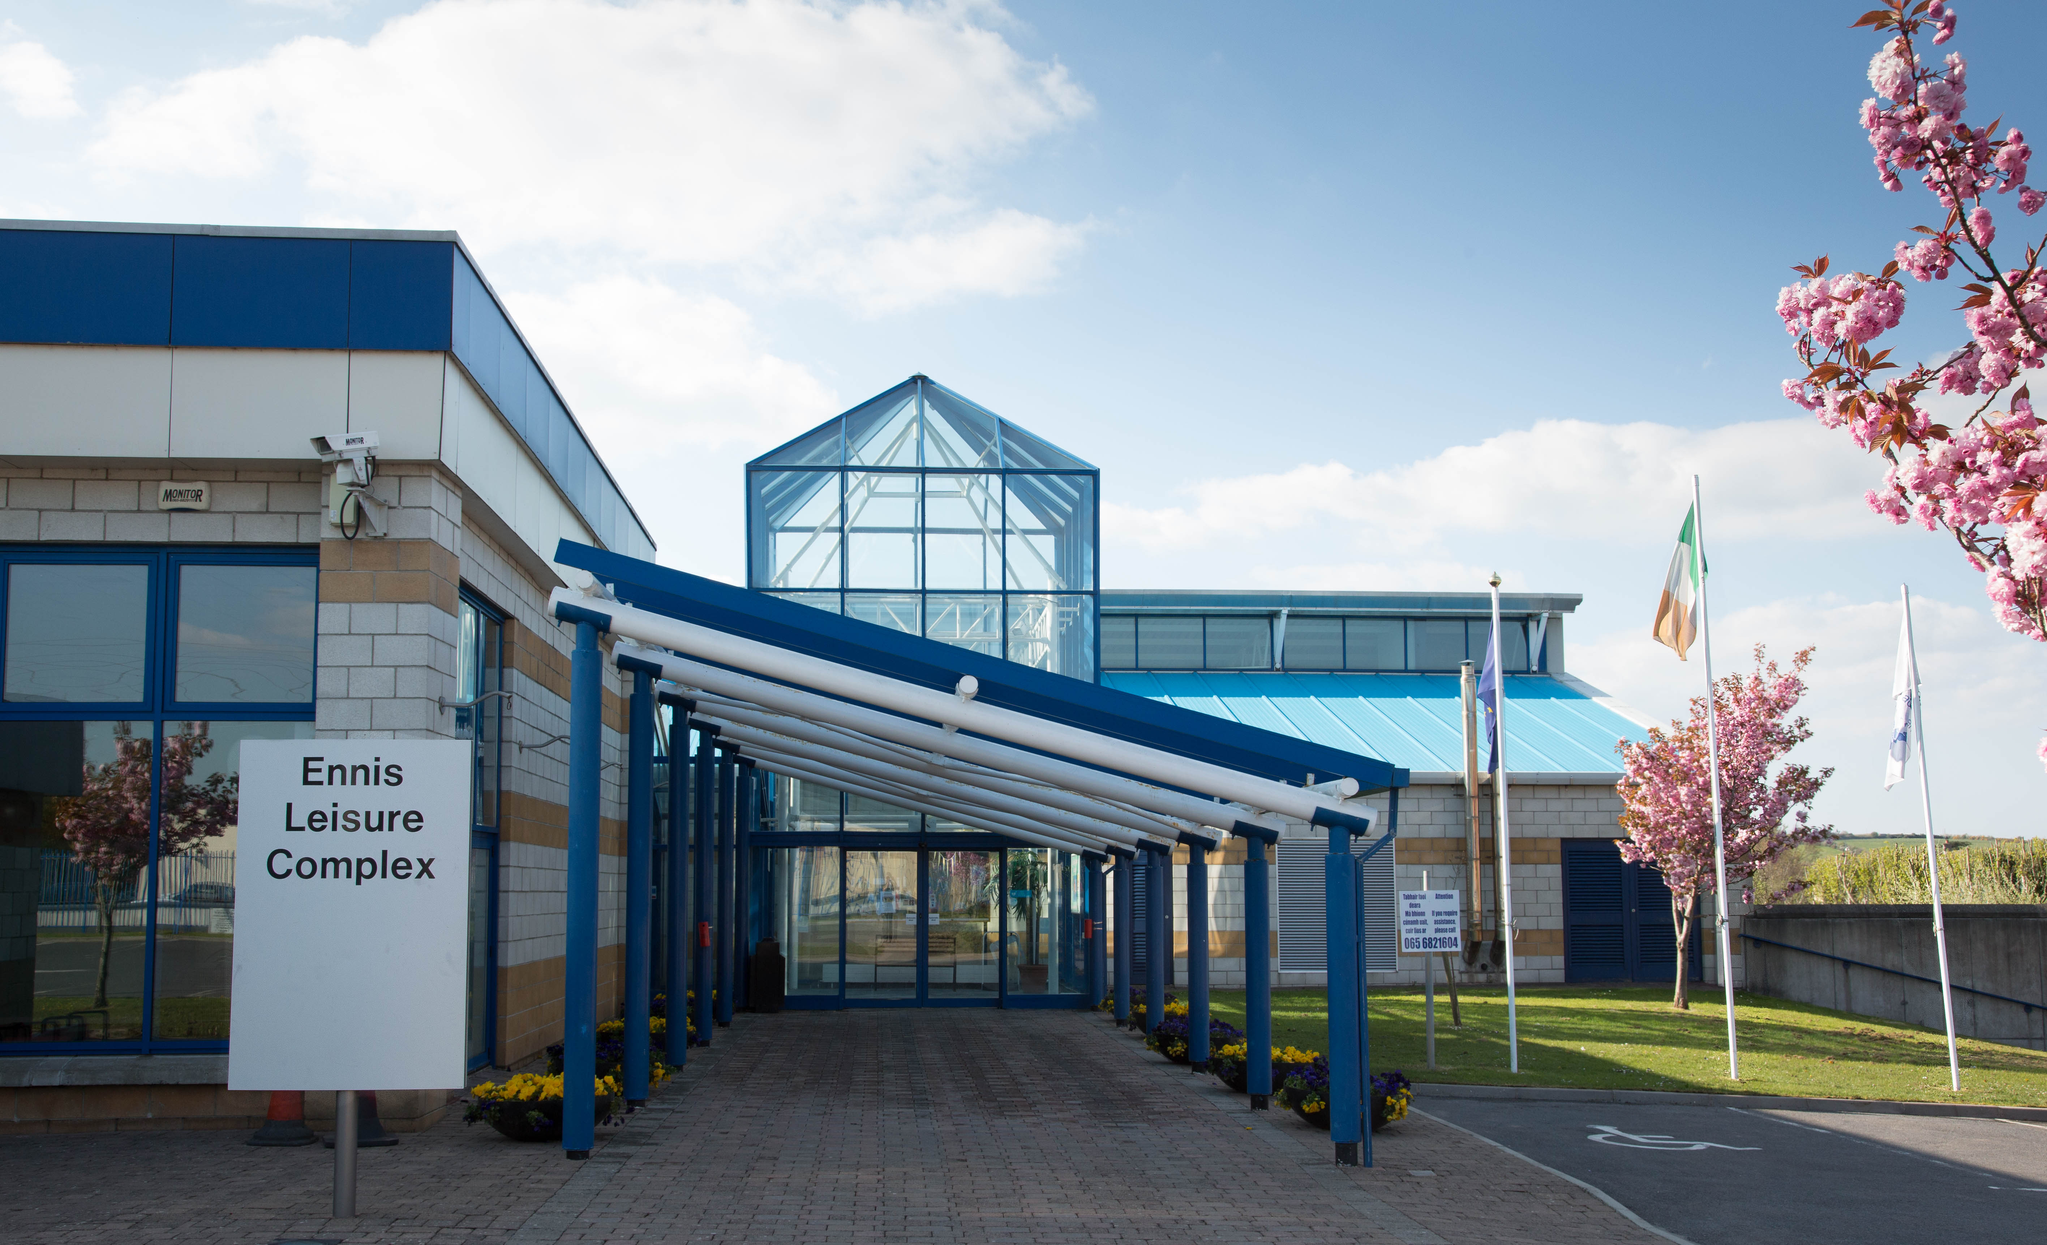
12 Classes to Christmas BOOT - CAMP
High intensity cardio & toning class – All levels welcome
4 week course (12 classes) - €60
Mon, Wed & Fri 6pm-7pm
Starting: 25th Nov – 21st Dec
To book contact reception
AQUA AEROBICS
A fun and exciting aerobics class in our 25m pool.
Mon & Wed 8.45pm-9.45pm
Tues & Fri 10am-11am
Pay as you go - €6.50, member - €2, senior €4.70
AEROBICS / STEP AEROBICS
Sue’s class uses the most dynamic fat stripping workout techniques, to define and tone your body.
Every Mon(Aerobics)7pm – 8pm
& Wed (Step) 7pm–8pm
Pay as you go - €6, member-€2

